**Lab 6 report salma soliman 900182325**

**Experiment 3&4:**

We implemented a full path module that combines all of the previous modules that we constructed in the previous labs. In experiment 3, we saw the output in the simulation. In experiment 4, we added the seven segment module to see the output on it.

**Simulation of the instructions:**

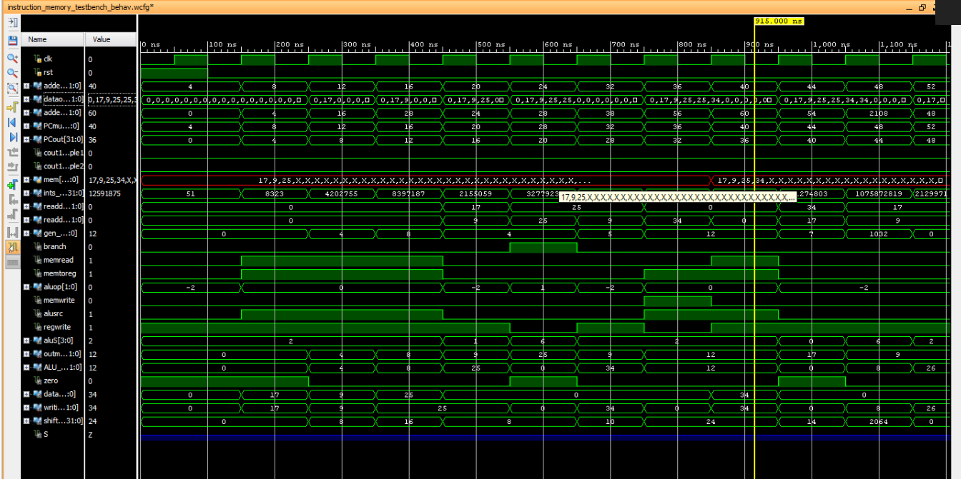

**SSD output in a certain case :**

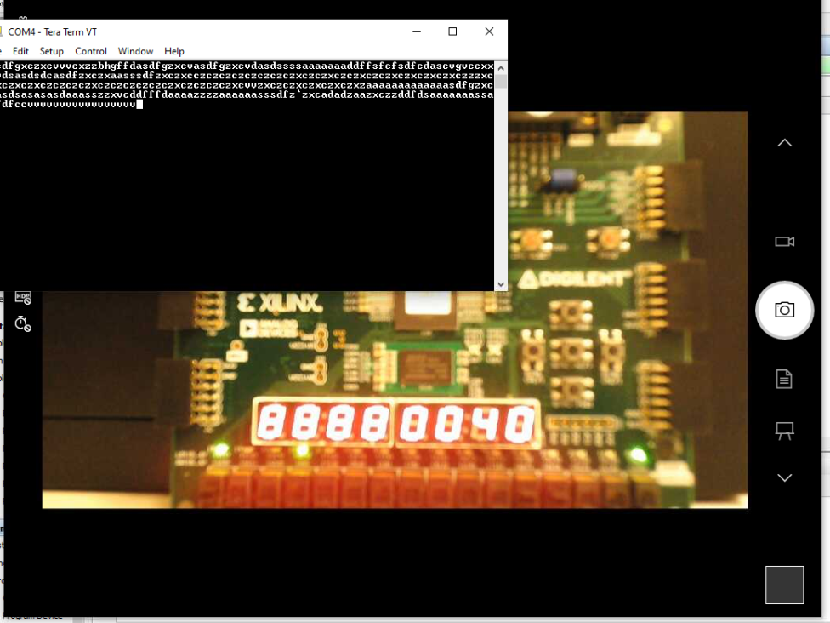

**Verification phase:**

In this phase, we provided an additional assembly code that can test the functionality of this processor. We initialized registers t4 , t5 , t6 by values of 0 , 1 and 10 respectively. The values of the relative PC is shown below beside each instruction. We are going to trace each instruction by tracing the signals values by inspecting the Seven Segment Display (SSD) and the leds below it. The SSD will display the corresponding number sent to it and the leds will represent different internal signals of the processor.

In the excel provided, sheet 1 is done based on expectations but sheet 2 is done based on what we saw on the FPGA.

**The additional assembly program :**

lw t4, 0(zero) → **pc =0**

lw t5, 4(zero) → **pc=4**

lw t6, 8(zero) → **pc=8**

loop:

beq t4,t6,exit → **pc=12**

add t4,t4,t5 → **pc=16**

beq zero,zero,loop → **pc=20**

exit:

sw t4, 12(zero) → **pc=24**

**The part of the code that handles what is shown on SSD and the leds :**

always @(*)

begin

case(LedSel)

2'b00 :

begin

leds[0]= regwrite;

leds[1]= alusrc;

leds[3:2]= aluop;

leds[4]= memread;

leds[5]= memwrite;

leds[6]= memtoreg;

leds[7]= branch;

end

2'b01:

begin

leds[3:0]=aluS;

leds [4]=zero;

leds[5]=branch&zero;

leds[7:6] =0;

end

2'b11:

leds[7:0]= {0,ints_out[6:0]}; // monitoring the opcode

default : leds[7:0]= 0;

endcase

end

always@(*) begin

case (ssdSel)

4'b0000:num = PCout;

4'b0001: num =PCout+4;

4'b0010: num = adder1;

4'b0011: num = PCmux;

4'b0100: num = readdata1;

4'b0101: num= readdata2;

4'b0110: num= ints_out[11:7];

4'b0111: num= gen_out;

4'b1000: num= shiftout;

4'b1001:num=outmux_input_alu;

4'b1010: num= ALU_result;

4'b1011:num=dataMem_out;

default : num = 0;

endcase

**Tracing this instruction lw t4, 0(zero) → pc =0**

case(LedSel)

2'b00 :

begin

leds[0]= regwrite;

leds[1]= alusrc;

leds[3:2]= aluop;

leds[4]= memread;

leds[5]= memwrite;

leds[6]= memtoreg;

leds[7]= branch;

end

The output should be 11001010

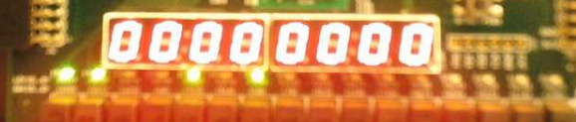

2'b01:

begin

leds[3:0]=aluS;

leds [4]=zero;

leds[5]=branch&zero;

leds[7:6] =0;

End

The output should be 0100 1000

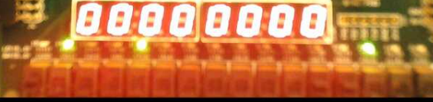

2'b11:

leds[7:0]= {0,ints_out[6:0]}; // monitoring the opcode

**The output should be 0000011**

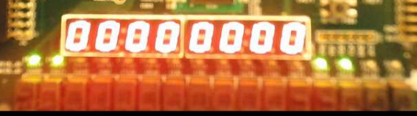

**Default value should be zero**

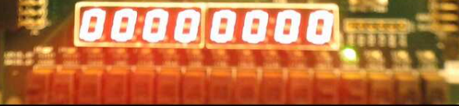

4'b0000:num = PCout;

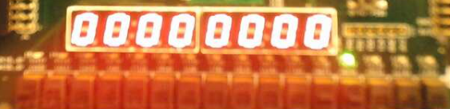

4'b0001: num =PCout+4;

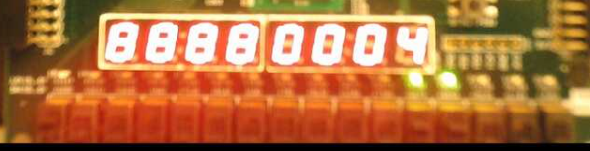

4'b0010: num = adder1;

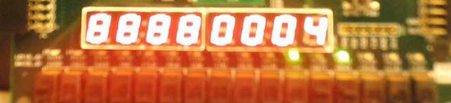

4'b0011: num = PCmux;

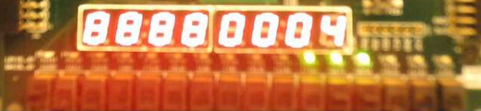

4'b0100: num = readdata1;

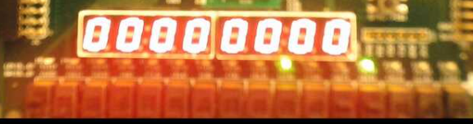

4'b0101: num= readdata2;

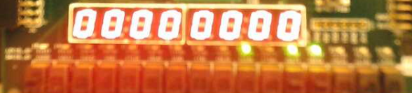

4'b0110: num= ints_out[11:7]; rd = 11101 =29

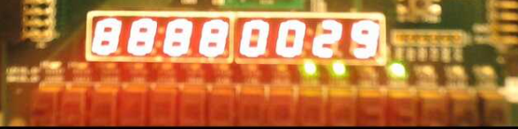

4'b0111: num= gen_out; imm = 0000 0000 000

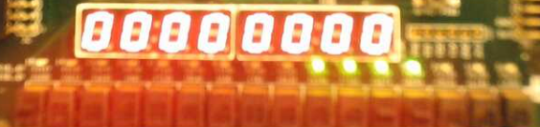

4'b1000: num= shiftout; imm * 2=0

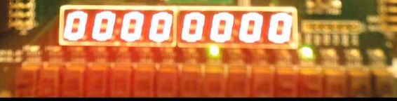

4'b1001:num=outmux_input_alu;

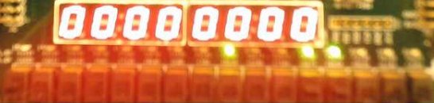

4'b1010: num= ALU_result;

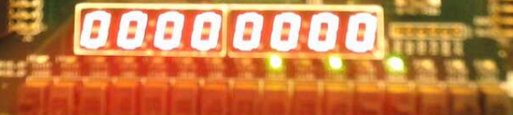

4'b1011:num=dataMem_out;

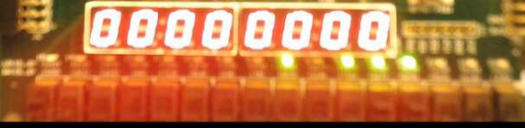

default : num = 0;

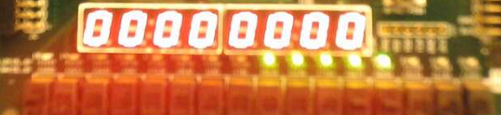

**Tracing this instruction** lw t5, 4(zero) → **pc=4**

case(LedSel)

2'b00 :

begin

leds[0]= regwrite;

leds[1]= alusrc;

leds[3:2]= aluop;

leds[4]= memread;

leds[5]= memwrite;

leds[6]= memtoreg;

leds[7]= branch;

end

The output should be 11001010

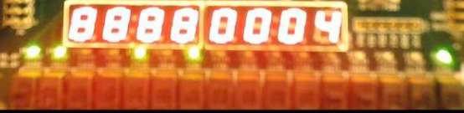

2'b01:

begin

leds[3:0]=aluS;

leds [4]=zero;

leds[5]=branch&zero;

leds[7:6] =0;

End

The output should be 00000010

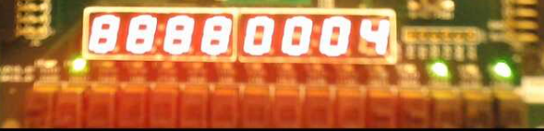

end

2'b11:

leds[7:0]= {0,ints_out[6:0]}; // monitoring the opcode

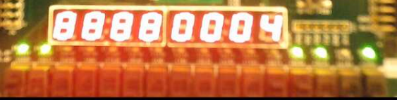

default : leds[7:0]= 0;

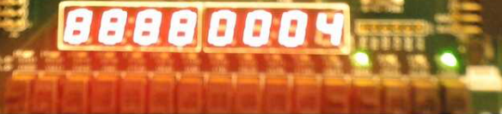

endcase

case (ssdSel)

4'b0000:num = PCout;



4'b0001: num =PCout+4;

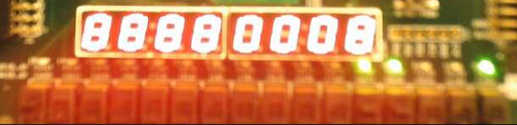

4'b0010: num = adder1;

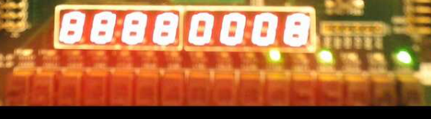

4'b0011: num = PCmux;

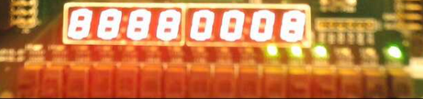

4'b0100: num = readdata1;

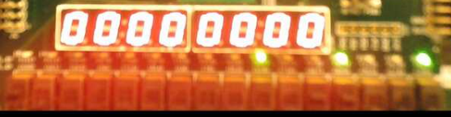

4'b0101: num= readdata2;

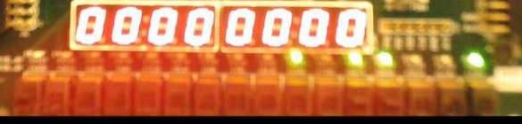

4'b0110: num= ints_out[11:7]; rd =30

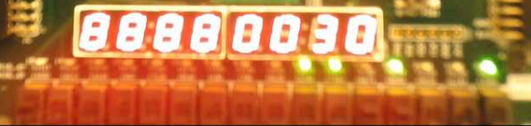

4'b0111: num= gen_out; imm =4

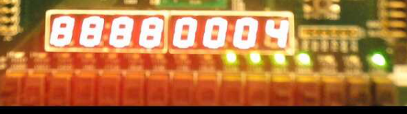

4'b1000: num= shiftout;

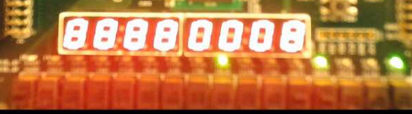

4'b1001:num=outmux_input_alu;

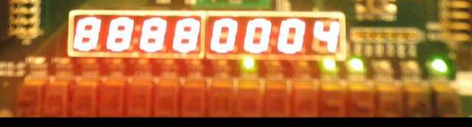

4'b1010: num= ALU_result;

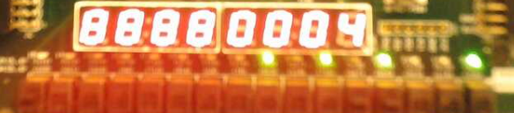

4'b1011:num=dataMem_out;

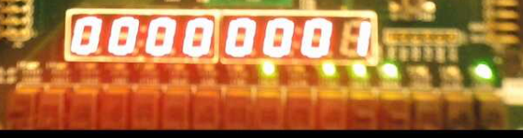

default : num = 0;

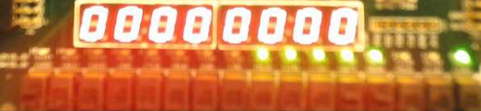

**Tracing the instruction beq zero,zero,loop → pc=20**

case (ssdSel)

4'b0000:num = PCout;

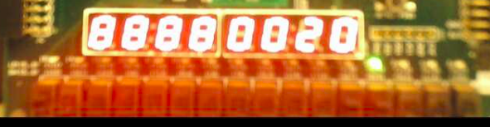

4'b0001: num =PCout+4;

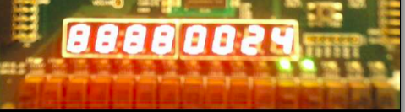

4'b0010: num = adder1;

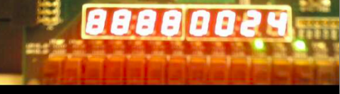

4'b0011: num = PCmux;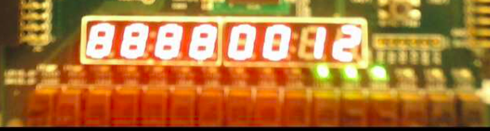

4'b0100: num = readdata1;

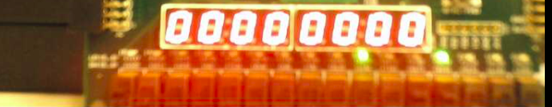

4'b0101: num= readdata2;

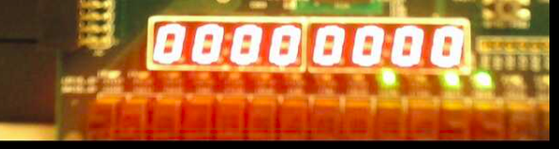

4'b0110: num= ints_out[11:7];

Imm[4:1][11] = [1100][1] = 24+1=25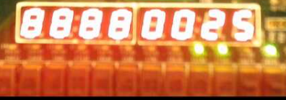

4'b0111: num= gen_out;

Immgen out = 1 1111 1111 1100 = 8188

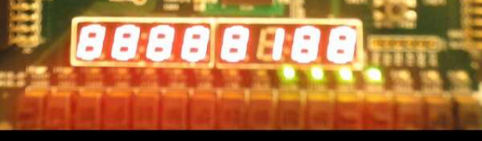

4'b1000: num= shiftout;

Shiftout = 1111111111000 =8184

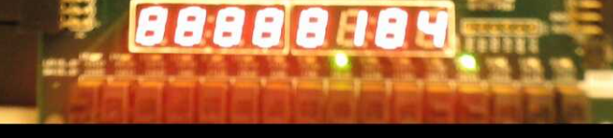

4'b1001:num=outmux_input_alu; register zero

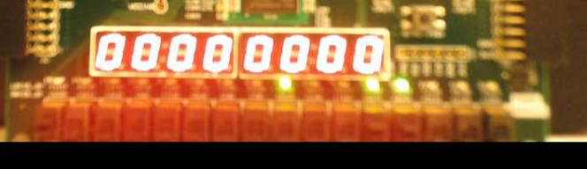

4'b1010: num= ALU_result; = zero

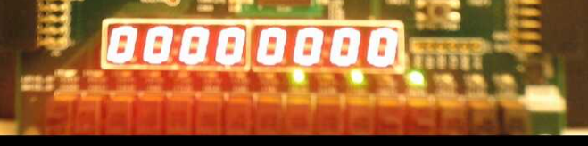

4'b1011:num=dataMem_out;

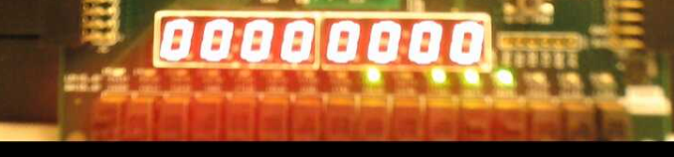

default : num = 0;

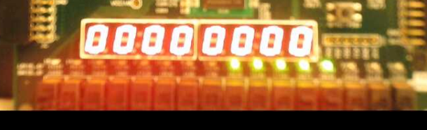

endcase

End

When ledsel = 00

We should see

Leds[0]= regwrite; 0

leds[1]= alusrc;0

leds[3:2]= aluop; 01

leds[4]= memread;0

leds[5]= memwrite;0

leds[6]= memtoreg;x

leds[7]= branch;1

Reading from left to right 00100011

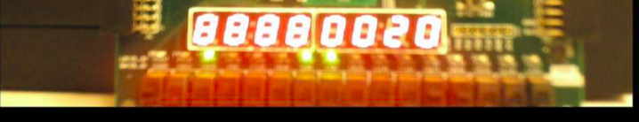

When ledsel = 01

We should see

leds[3:0]=aluS; 0110 subtract

leds [4]=zero; 1

leds[5]=branch&zero; 1

leds[7:6] =0;

Reading from left to right 0110110

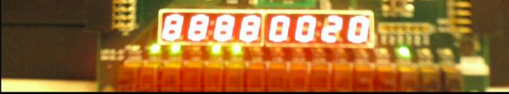

When ledsel = 11

We should see

leds[7:0]= {0,ints_out[6:0]}; // monotring the opcode 1100011

